**Freelancing Application MERN**

**1. INTRODUCTION**

**1.1 Project Overview**

The project titled "Freelancing Application MERN" aims to SB Works connects clients and freelancers through project postings, bidding, and real-time communication. Freelancers on SB Works benefit from a straightforward project submission process. After completing the assigned project, freelancers can submit their work directly through the platform, offering clients a hassle-free experience. Clients have the opportunity to review the work and provide feedback, fostering a collaborative environment that values excellence.

**1.2 Purpose**

SB Works is a freelancing platform that connects clients with skilled freelancers. It enables project posting, bidding, and real-time collaboration through an intuitive UI. The admin ensures secure transactions and smooth communication.

**2. IDEATION PHASE**

**2.1 Problem Statement**

In the modern digital economy, the demand for freelance services is growing rapidly. However, both clients and freelancers face significant challenges in engaging effectively on existing platforms. Clients often struggle to find qualified professionals, communicate seamlessly, and manage project submissions. On the other hand, freelancers face difficulties in discovering relevant projects, showcasing their skills, and receiving timely feedback and payments.

* Allows clients to post projects with clear details and manage submissions easily.
* Enables freelancers to search and bid for suitable projects, communicate with clients, and deliver high-quality work.
* Provides an administrative layer to monitor interactions, resolve conflicts, and maintain platform integrity.

**2.2 Empathy Map Canvas**

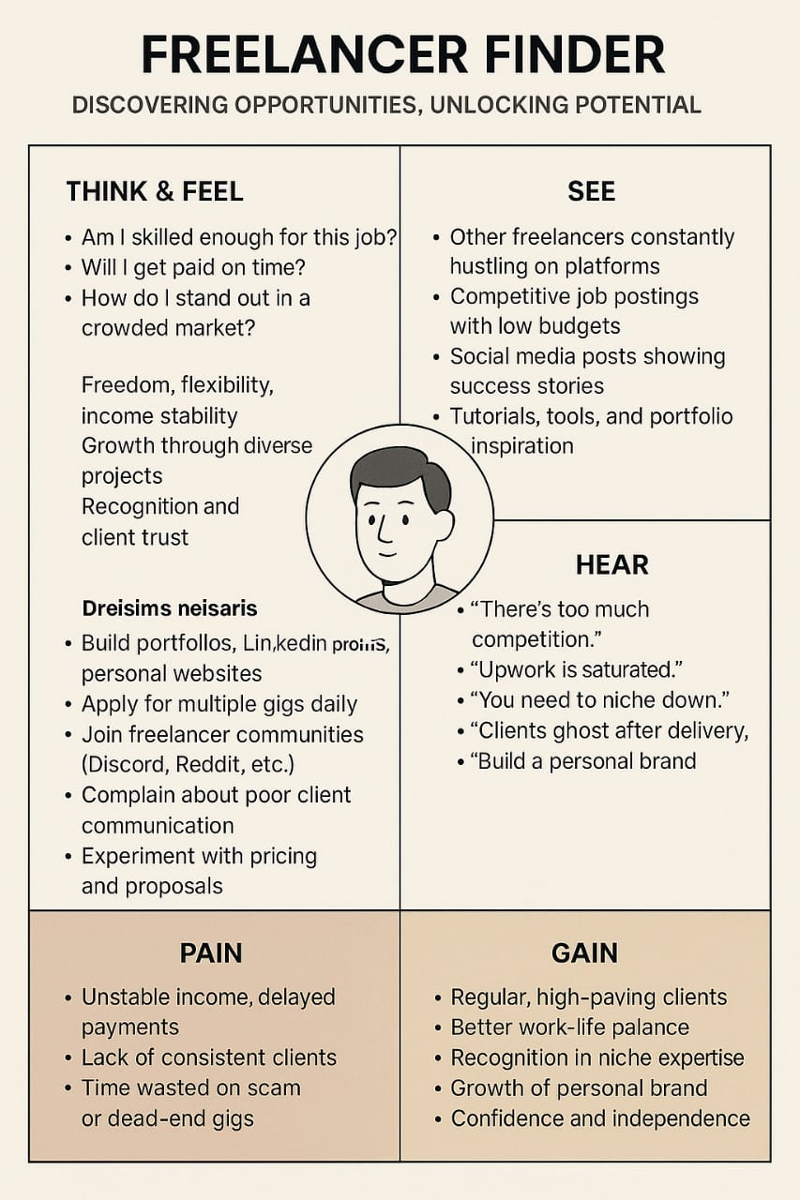

**2.3 Brainstorming**

During the brainstorming session, the team explored ideas such as:

• Intuitive project posting and browsing interface

• Real-time chat between client and freelancer

• Admin-mediated dispute resolution and moderation

• Role-based dashboards (client, freelancer, admin)

• Notification system via email and in-app alerts

• Review and rating system for freelancers and clients

• Freelance profile building and skill tagging

**3. REQUIREMENT ANALYSIS**

**3.1 Customer Journey Map**

**• Awareness**:The user (client or freelancer) learns about SB Works via social media, referrals, or search engines.

**• Registration/Login**:  
🔹 Users sign up or log in.  
🔹 Role-based access: Client / Freelancer / Admin  
🔹 Email verification or Google sign-in options.

• **Profile Setup**🔹 Freelancers create detailed profiles including skills, experience, portfolio, and hourly rate.  
🔹 Clients set up company/project information and post job requirements.

• **Project Discovery / Posting**🔹 Clients post project details including scope, budget, and timeline.  
🔹 Freelancers browse project listings and filter by skill, category, or budget.

• **Bidding & Proposal**🔹 Freelancers submit proposals with quotes and portfolio samples.  
🔹 Clients review proposals, view freelancer ratings, and shortlist candidates.

**• Communication**  
🔹 In-app chat system allows discussion of project details, deadlines, and clarifications.  
🔹 Admin may mediate if disputes or issues arise.

**• Project Execution**  
🔹 Freelancers work on projects and upload deliverables through the platform.  
🔹 Clients track progress and request revisions if necessary.

• **Review & Payment**🔹 Client accepts final work and processes payment.  
🔹 Freelancer receives confirmation and rating.  
🔹 Both parties provide feedback.

• **Retention & Re-engagement**  
🔹 Users receive emails about new project matches or freelance recommendations.  
🔹 Performance badges, testimonials, and verified status boost freelancer visibility

**3.2 Solution Requirement**

Functional Requirements:

* User registration and role-based login (Client, Freelancer, Admin)
* Project posting by clients
* Project browsing and bidding by freelancers
* In-app messaging between freelancers and clients
* File upload for project submissions
* Admin dashboard for platform monitoring
* Ratings and reviews after project completion
* Notification system for important events

🔧 Non-Functional Requirements (Key Points)

* Fast load time (<2 seconds)
* Secure authentication using JWT/Firebase
* Mobile-responsive design
* 99.9% system uptime
* Scalable architecture to handle user growth
* User-friendly interface with easy navigation

**3.3 Data Flow Diagram**

Level 0 DFD:

External Entities: Client, Freelancer, Admin

Processes: User Management, Project Management, Application Handling, Communication, Admin Monitoring

Data Stores: User Database, Project Database, Chat Database

**3.4 Technology Stack**

* Frontend: React.js / Flutter (for mobile)
* Backend: Node.js / Django
* Database: MongoDB / PostgreSQL
* Authentication: Firebase Auth / JWT
* Hosting: AWS / Firebase Hosting

**4. PROJECT DESIGN**

**4.1 Problem-Solution Fit:**

The proposed solution addresses the inefficiencies and lack of streamlined collaboration in current freelancing systems. SB Works offers a centralized, secure digital platform accessible from any device, enabling clients and freelancers to connect, collaborate, and complete projects effectively.

**4.2 Proposed Solution**

A responsive web application where:  
● Clients can post, manage, and review projects  
● Freelancers can browse projects, submit proposals, and deliver work  
● Admins can monitor activity, mediate disputes, and ensure policy compliance

**4.3 Solution Architecture**

Architecture Type: Client–Server Model

Layers:  
● Presentation Layer: Web UI built with React.js  
● Business Logic Layer: Node.js Express API with RESTful services  
● Data Layer: MongoDB for user, project, and chat data

**5. PROJECT PLANNING & SCHEDULING**

5.1 Project Planning  
Agile methodology was followed using 6-day sprints:

Sprint 1 (16–18 June 2025): User Authentication and Role Management  
Sprint 2 (19–20 June 2025): Project Posting & Freelance Bidding  
Sprint 3 (21–23 June 2025): Chat Integration & Profile Management  
Sprint 4 (24–26 June 2025): Admin Dashboard & Review System

**6. FUNCTIONAL AND PERFORMANCE TESTING**

**6.1 Performance Testing**

Tools Used:  
● JMeter for simulating platform load  
● Postman for API response validation

Test Scenarios:  
● Simulated 100 concurrent users posting and bidding on projects  
● Measured API response time (<1.5 seconds) under load  
● Validated database performance and index efficiency

**7. RESULTS**

* Application handled peak load smoothly
* Average response time: 1.2 seconds
* No crashes or timeouts recorded

7.1 Output Screenshots:

HOME PAGE :

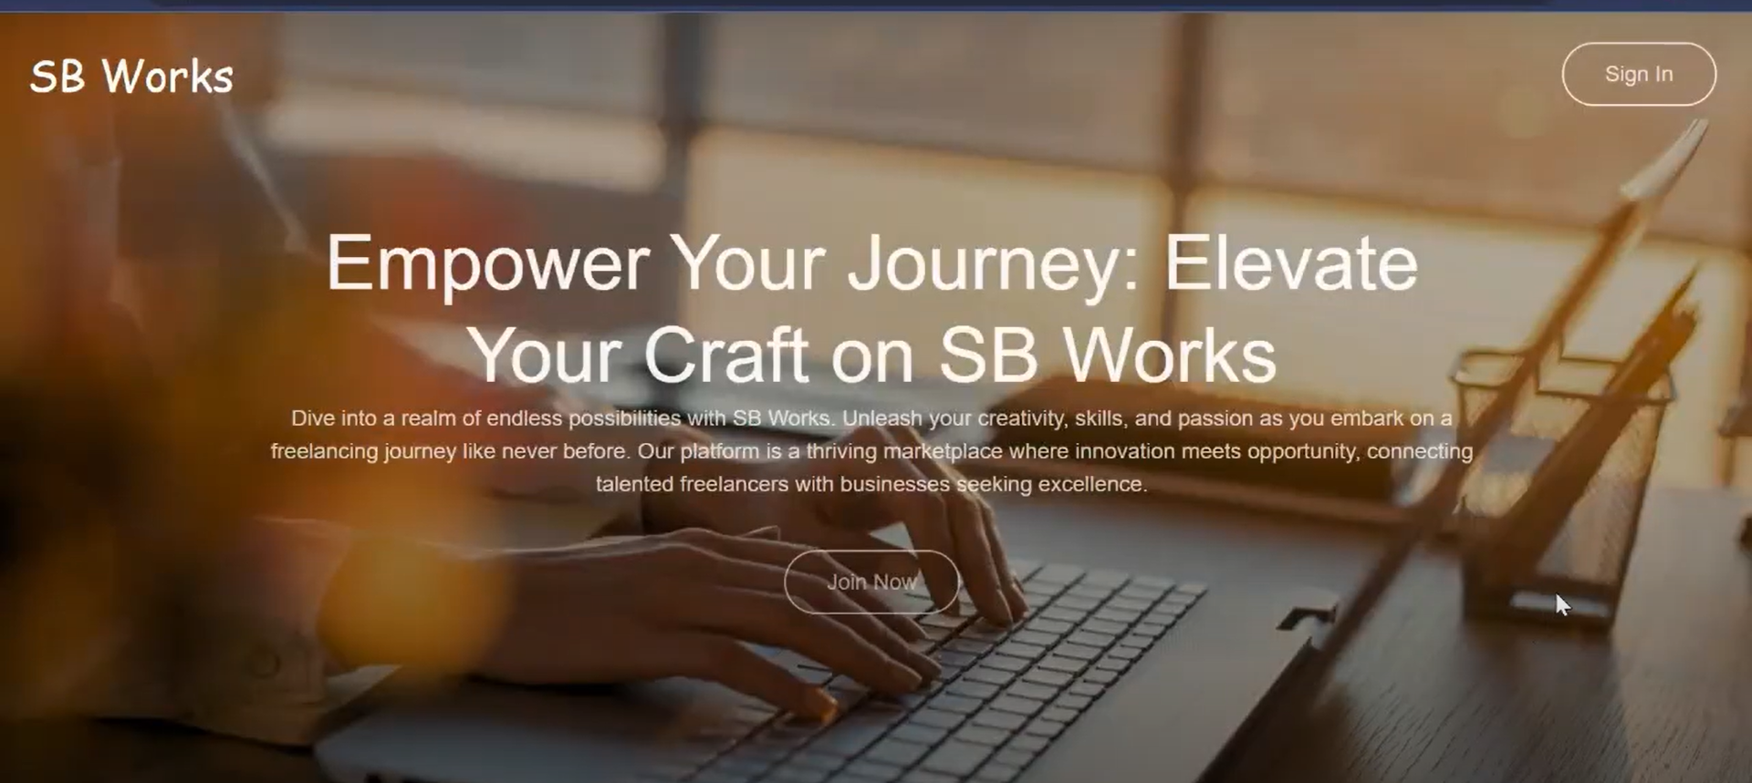

LOGIN PAGE:

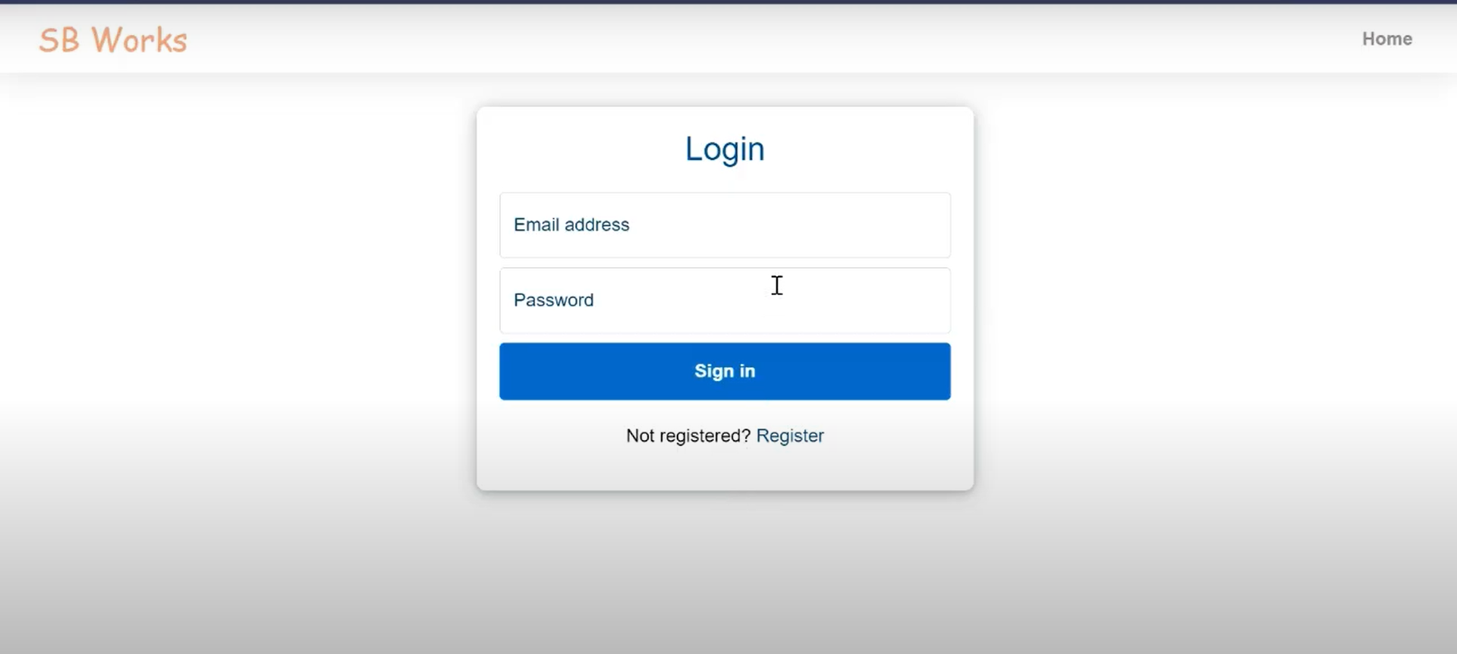

DASHBOARD:

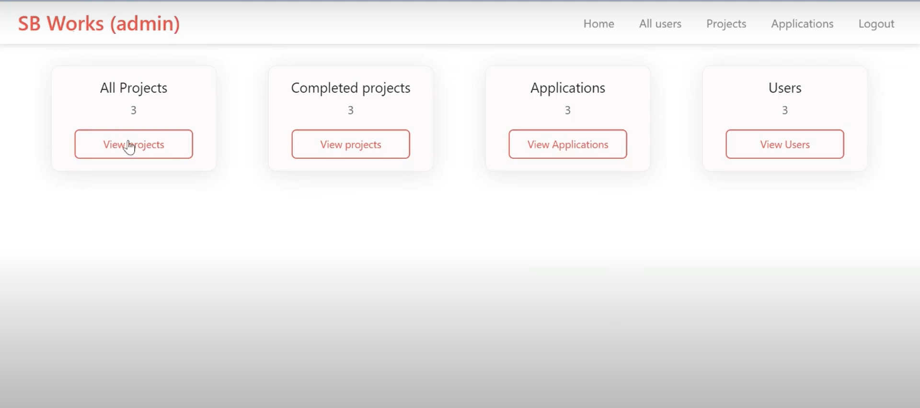

**8. ADVANTAGES & DISADVANTAGES**

Advantages:  
● Reduces manual effort in project management and communication  
● Enhances user experience with an intuitive and responsive interface  
● Provides a centralized platform for posting, bidding, chatting, and delivery.

Disadvantages:

● Requires a stable internet connection for real-time collaboration  
● Initial development and deployment costs may be high  
● Some users (especially first-time freelancers or clients) may face a slight learning curve

**9. CONCLUSION**

The SB Works project offers a modern and efficient digital solution for freelancing collaboration. By integrating intuitive interfaces, robust backend architecture, and real-time communication tools, the platform bridges the gap between clients and freelancers. With structured planning and Agile development, SB Works enhances project transparency, reduces friction, and promotes reliable freelance engagement..

**10. FUTURE SCOPE**

● Integration of secure payment gateways and milestone-based payments  
● Mobile app version for Android and iOS  
● AI-based project–freelancer matching engine  
● Portfolio verification and freelancer badge system  
● Multi-language interface and international currency support  
● Advanced analytics for admins and clients

**11. APPENDIX**

Source Code:

https://github.com/medaraakshitha